The London Zoo
1.Data Requirements:
All tables use snake_case naming conventions throughout, consistent with the implemented MySQL schema. Primary keys are unsigned integers with AUTO_INCREMENT. Foreign key relationships enforce referential integrity using CASCADE or SET NULL delete behaviour as appropriate. Timestamps are auto-managed by the database engine.

Table 1: users
Stores authentication credentials and access roles for both visitors and staff. Passwords are stored as bcrypt hashes (never plaintext). The role ENUM restricts values to visitor or staff, enabling access control for the staff dashboard. The edited_at timestamp provides an audit trail supporting GDPR accountability obligations.
Field Name | Data Type | Constraints | Description | Validation / Error Handling
id | INT UNSIGNED | PK, AUTO_INCREMENT | Unique user identifier | Auto-generated; cannot be null or duplicate
email | VARCHAR(225) | NOT NULL, UNIQUE | User login email address | Rejected if duplicate or empty; max 225 chars; indexed
password_hash | VARCHAR(225) | NOT NULL | bcrypt hash (plaintext never stored) | Cannot be null; bcrypt applied before storage
role | ENUM | DEFAULT visitor | Access role: visitor or staff | Only accepts visitor or staff; invalid values rejected by ENUM
reset_token | CHAR(64) | DEFAULT NULL | 64-char password reset token | Nullable; expiry enforced at application layer
created_at | TIMESTAMP | DEFAULT CURRENT_TIMESTAMP | Account creation timestamp | Auto-set on insert; supports GDPR audit trail
edited_at | TIMESTAMP | ON UPDATE CURRENT_TIMESTAMP | Last modification timestamp | Auto-updated on any row change; GDPR accountability

Table 2: user_preferences
Stores visitor notification settings and personalised attraction preferences. The UNIQUE constraint on user_id enforces a one-to-one relationship with the users table. ON DELETE CASCADE ensures preferences are removed automatically if the associated user account is deleted, supporting GDPR data minimisation.
Field Name | Data Type | Constraints | Description | Validation / Error Handling
id | INT UNSIGNED | PK, AUTO_INCREMENT | Unique preferences record identifier | Auto-generated
user_id | INT UNSIGNED | NOT NULL, UNIQUE, FK | Links to users(id); one row per user | CASCADE delete: removed when user deleted; UNIQUE enforces 1-to-1
notifications_enabled | BOOLEAN | DEFAULT TRUE | Controls whether push alerts are sent | Accepts TRUE/FALSE only; defaults to TRUE
preferred_attractions | TEXT | JSON, nullable | JSON array of attraction names e.g. [penguins] | App layer validates JSON format before write; null accepted for new users
distance_alert_threshold | INT | DEFAULT 500 | Proximity alert distance in metres | Must be positive integer; defaults to 500m; app-layer range check
created_at | TIMESTAMP | DEFAULT CURRENT_TIMESTAMP | Record creation timestamp | Auto-set on insert
updated_at | TIMESTAMP | ON UPDATE CURRENT_TIMESTAMP | Last modification timestamp | Auto-updated on any change

Table 3: attractions
Stores all zoo attraction records. GPS coordinates use DECIMAL(10,8) and DECIMAL(11,8) for latitude and longitude respectively, providing sub-metre precision required by the navigation algorithm. The category field is indexed to support efficient filtering by the personalisation suggestion feature.
Field Name | Data Type | Constraints | Description | Validation / Error Handling
id | INT UNSIGNED | PK, AUTO_INCREMENT | Unique attraction identifier | Referenced by queue_status, notifications, staff_metrics
name | VARCHAR(150) | NOT NULL, UNIQUE | Attraction display name | Max 150 chars; must be unique; cannot be null
description | TEXT | Nullable | Descriptive text shown to visitors | No max length; null permitted
category | VARCHAR(100) | Indexed, nullable | Category label e.g. Reptiles, Birds, Mammals | Indexed for fast filtering; used by suggestion algorithm
latitude | DECIMAL(10,8) | NOT NULL | GPS latitude coordinate (8dp precision) | Range -90 to +90; required for navigation algorithm
longitude | DECIMAL(11,8) | NOT NULL | GPS longitude coordinate (8dp precision) | Range -180 to +180; required for navigation algorithm
estimated_duration_minutes | INT UNSIGNED | DEFAULT 30 | Suggested visit duration in minutes | Must be positive; defaults to 30 mins
capacity | INT UNSIGNED | DEFAULT 100 | Max concurrent visitor capacity | Must be positive; used by queue monitoring logic
is_open | BOOLEAN | DEFAULT TRUE | Live open/closed status of the attraction | Toggled by staff; triggers status notifications on change
created_at | TIMESTAMP | DEFAULT CURRENT_TIMESTAMP | Record creation timestamp | Auto-set on insert
updated_at | TIMESTAMP | ON UPDATE CURRENT_TIMESTAMP | Last update timestamp | Auto-updated on any change

Table 4: queue_status
Stores live queue data per attraction. A UNIQUE constraint on attraction_id enforces a one-to-one relationship, ensuring only one active queue record exists per attraction at any time. UNSIGNED integer types prevent invalid negative queue lengths.
Field Name | Data Type | Constraints | Description | Validation / Error Handling
id | INT UNSIGNED | PK, AUTO_INCREMENT | Unique queue record identifier | Auto-generated
attraction_id | INT UNSIGNED | NOT NULL, FK, UNIQUE | Links to attractions(id); one queue per attraction | CASCADE delete; UNIQUE enforces one active record per attraction
queue_length | INT UNSIGNED | DEFAULT 0 | Current number of visitors waiting | UNSIGNED prevents negative values; defaults to 0
estimated_wait_minutes | INT UNSIGNED | DEFAULT 0 | Estimated wait time in minutes | UNSIGNED prevents negative values; recalculated on each update
last_updated | TIMESTAMP | ON UPDATE CURRENT_TIMESTAMP | Timestamp of most recent queue update | Used by alert algorithm to detect stale data

Table 5: notifications
Stores system-generated alerts delivered to users. The type field uses ENUM to ensure only valid notification categories are accepted. A composite index on (user_id, is_read) optimises the frequent query of fetching unread notifications for a specific user.
Field Name | Data Type | Constraints | Description | Validation / Error Handling
id | INT UNSIGNED | PK, AUTO_INCREMENT | Unique notification identifier | Auto-generated
user_id | INT UNSIGNED | NOT NULL, FK | Recipient user; links to users(id) | CASCADE delete: notification removed if user deleted
attraction_id | INT UNSIGNED | Nullable, FK | Optional link to a specific attraction | SET NULL on attraction delete; allows general notifications
type | ENUM | DEFAULT general | Type: queue_alert, status_update, or general | Constrained to three values; invalid types rejected by ENUM
message | TEXT | NOT NULL | Notification message text displayed to user | Cannot be null or empty; generated by alert algorithm
is_read | BOOLEAN | DEFAULT FALSE | Read/unread status | Defaults to FALSE; composite index with user_id for fast unread queries
created_at | TIMESTAMP | DEFAULT CURRENT_TIMESTAMP | Notification creation timestamp | Auto-set; used for sorting and expiry logic

Table 6: staff_metrics
Stores daily performance metrics per attraction for the staff dashboard. A composite UNIQUE constraint on (attraction_id, metric_date) prevents duplicate daily records per attraction. DECIMAL(5,2) for uptime_percentage supports precise reporting.
Field Name | Data Type | Constraints | Description | Validation / Error Handling
id | INT UNSIGNED | PK, AUTO_INCREMENT | Unique metrics record identifier | Auto-generated
attraction_id | INT UNSIGNED | NOT NULL, FK | Links to attractions(id) | CASCADE delete; metrics removed if attraction deleted
metric_date | DATE | NOT NULL | Date of the recorded metrics | Composite UNIQUE with attraction_id prevents duplicate records
ticket_sales | INT UNSIGNED | DEFAULT 0 | Tickets sold for this attraction on this date | UNSIGNED prevents negative values; updated by sales processing
uptime_percentage | DECIMAL(5,2) | DEFAULT 100.00 | Attraction operational uptime percentage | Range 0.00-100.00; validated at application layer
visitors_count | INT UNSIGNED | DEFAULT 0 | Total visitors at the attraction that day | UNSIGNED prevents negative values; updated in real time
recorded_at | TIMESTAMP | DEFAULT CURRENT_TIMESTAMP | Record creation timestamp | Auto-set on insert

Design Note - preferred_attractions field (user_preferences): The preferred_attractions field stores a JSON-encoded TEXT array rather than a separate normalised junction table. This decision was made because the system reads and overwrites the full preference array in a single operation, making a multi-row normalised structure unnecessarily complex for this use case. The trade-off is reduced individual-item queryability, which is acceptable given the suggestion algorithm operates on the full array. JSON format is validated at the application layer before any write operation.
2.System Decomposition:
The proposed system can be decomposed into several key components, including user account management, visitor information management, navigation and mapping, queue and attraction monitoring, communication and notifications, and data management and analytics. Each component is responsible for a specific area of functionality and can be developed and maintained independently as part of the overall system.
Core components such as user account management and data storage would be developed first, as they provide the foundation for authentication, personalisation, and secure access to system data. Navigation and location services, along with queue and attraction information modules, would be built next, as these rely on access to stored data and user context. The notification and alert system would then be integrated to react to changes in queue data and user preferences. Finally, the staff data management and analytics module would be developed to allow authorised staff to analyse stored performance data, building on all previously established data sources.

3.Interface Design:
The following section presents a low-fidelity textual wireframe illustrating the structure and layout of key system pages.

Home / Landing Page
[Header: Logo | Menu | User Account and Personalisation Page]
[Navigation: Home | Navigation Page | Queue and Information Page | Staff Data
Dashboard]
[Quick Access: Explore Zoo | View Attractions | Check Queues | Alerts and Notifications]
[Main Section: Home Page]
[Footer: Help | Accessibility | Contact]

Navigation Page
[Header: Logo | Menu | User Account and Personalisation Page]
[Navigation: Home | Navigation Page | Queue and Information Page | Staff Data Dashboard]
[Quick Access: Explore Zoo | View Attractions | Check Queues | Alerts and Notifications]
[Main Section: Zoo Map]
[Current Location: Location]
[Selection: Destination]
[Display: Estimated Travel Time and Distance]
[Footer: Help | Accessibility | Contact]

Queue and Information Page
[Header: Logo | Menu | User Account and Personalisation Page]
[Navigation: Home | Navigation Page | Queue and Information Page | Staff Data Dashboard]
[Quick Access: Explore Zoo | View Attractions | Check Queues | Alerts and Notifications]
[Main Section: Queue Times]
[Display: Attraction Status]
[Button: Alerts and Notifications]
[Display: Information Panels]
[Footer: Help | Accessibility | Contact]

Staff Data Dashboard
[Header: Logo | Menu | Staff Account Management]
[Navigation: Home | Navigation Page | Queue and Information Page | Staff Data Dashboard]
[Admin Tools: Attraction performance data | Live queue analytics | System alerts]
[Main Section: Data Views]
[Button: Filters]
[Display: Analytic Panels]
[Footer: Help | Accessibility | Contact]

9.Algorithm Design:
9.1 Navigation route calculation:
Algorithm Name: Navigation Route & ETA
User: Visitor
Data Source: attractions table ( id , name , latitude and longitude)
Inputs: Destination ID and User Location
Outputs: Route displayed + estimated time + distance
Errors/Exceptions: Location unavailable, invalid destination , User not on navigation page

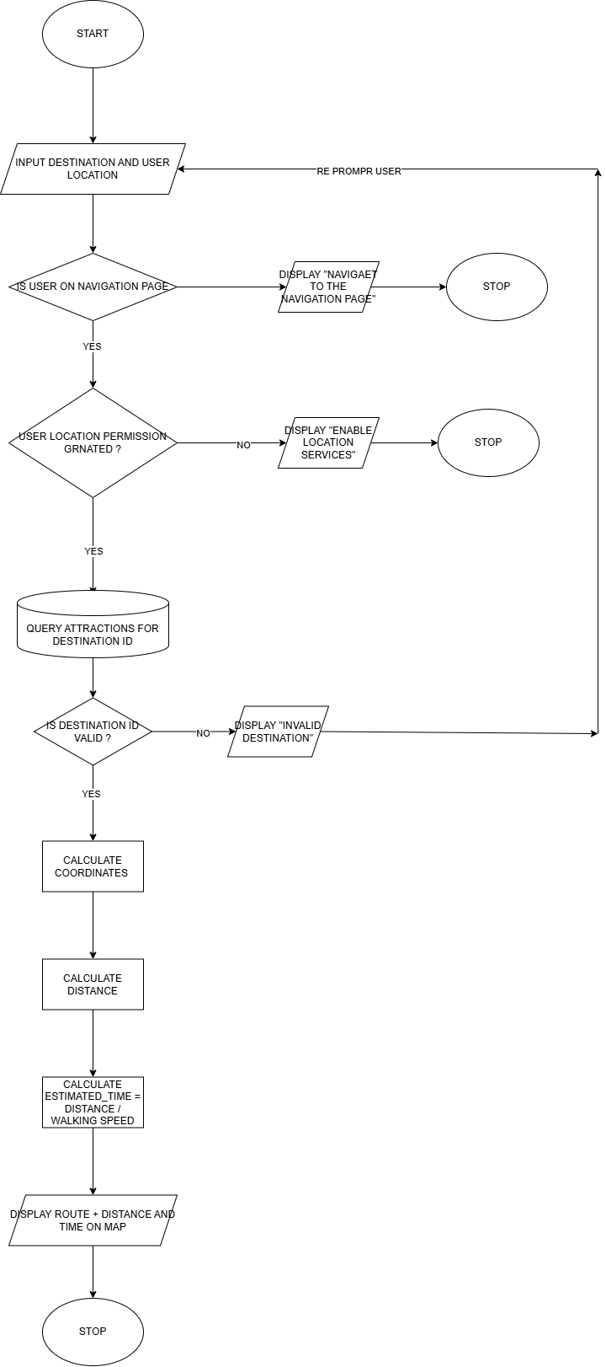

9.2 Queue alerts and notifications logic:
Algorithm Name: Queue Time Alert System.
User: Visitor
Data Source: user preferences( notifications_enabled and distance_alert_threshold) Queue status table ( queue_length , estimated_wait_minutes and last_updated) and notifications table( insert on alert trigger)
Inputs: User ID and Attraction ID
Outputs: Notification Displaying Attraction Queue Time or monitorung queue times.
Errors/Exceptions: Notifications Muted, Invalid Attraction Queue Data Unavailable and Queue within normal range.
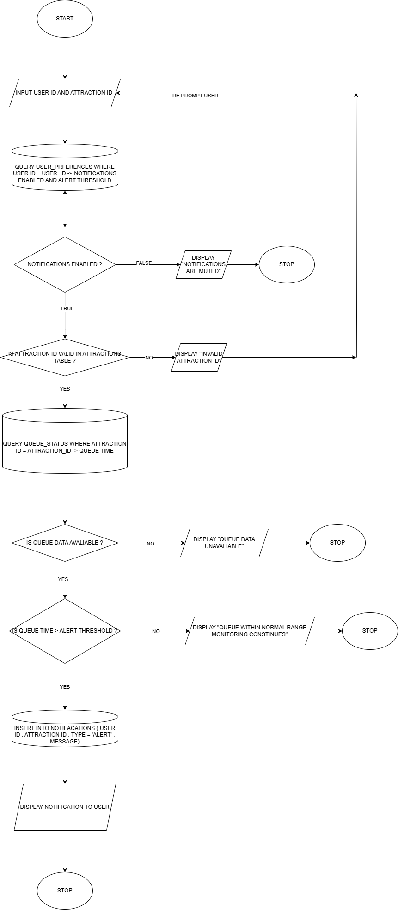

9.3 Personalised suggestions update:
Algorithm Name: Personalised Suggestions Update
User: Visitor
Input: User Id and attraction Id
Data source: user table ( id and role) , attractions table (id and category) and user_preferences( preferred_attractions , read and update)
Outputs: Updated list of suggested attractions
Errors / Exceptions: User not logged in and Interaction data unavailable
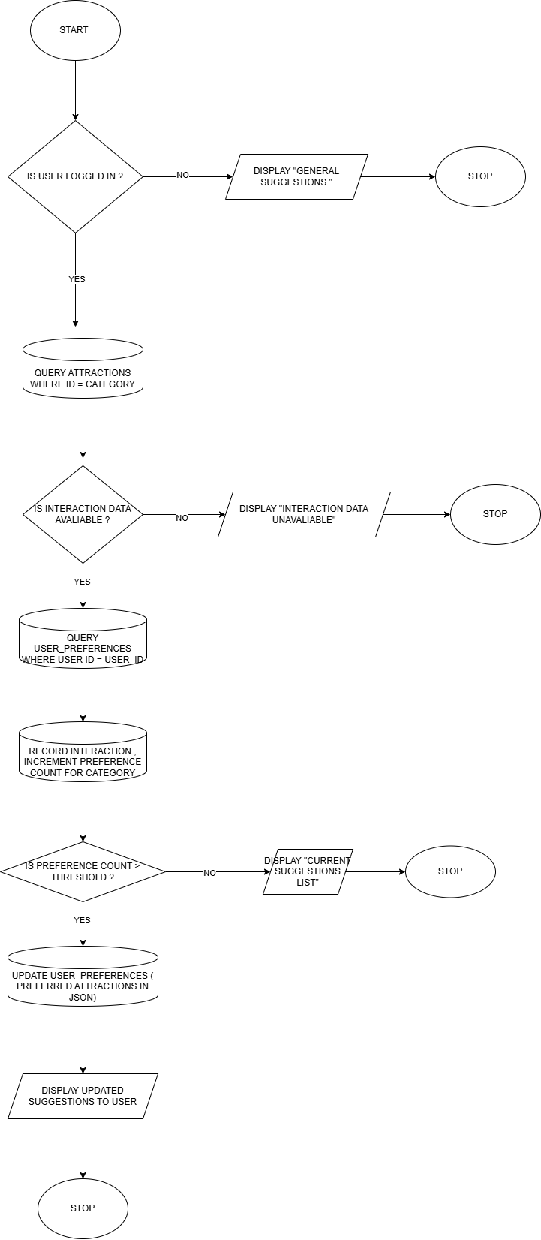

9.4 Staff Data Filtering and Analytics Display:
Algorithm Name: Staff data filtering and analytics display
User: Staff Member
Inputs: Staff ID , attraction filter , date range start and date range end
Data Source: user table , attractions table and staff metrics table
Outputs: Updated analytics panels based on selected filter
Errors/Exceptions: User not logged in, system downtime, no results found, Invalid date range and Invalid attraction.
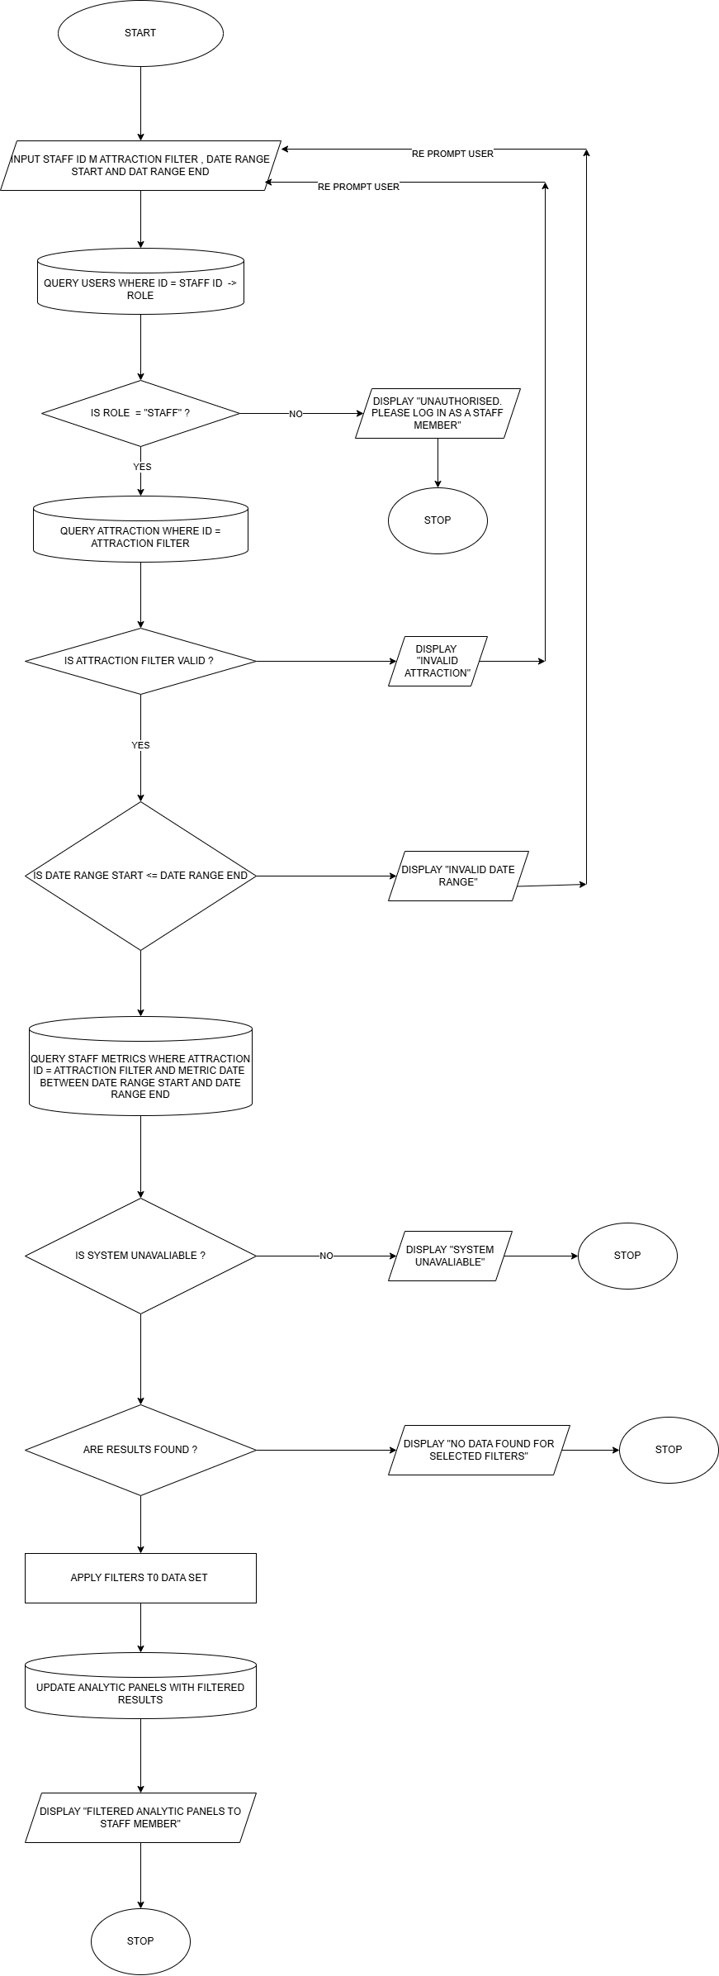

10. Testing Strategy:
10.1 Overview:
Testing will be carried out throughout the system development lifecycle to ensure that all components of the London Zoo digital platform function correctly both individually and when integrated. The purpose of testing is to confirm that the system meets its functional and non-functional requirements, handles invalid or unexpected input appropriately, and provides reliable and secure experience for both visitors and staff.
Testing will also support iterative improvement by identifying defects early and validating fixes through re-testing.
10.2 Testing Approach:
10.2.1Black Box Testing
Black-box Testing will be used to validate system functionality from the perspective of end users and staff, without reference to the internal implementation of the code. This approach ensures that the system inputs and outputs behave as expected and that user interactions align with system requirements.
Black box testing will be applied to:
- Navigation and route calculation, using valid and invalid attraction destinations
- Queue time alerts and notifications, including threshold-based triggers
- User authentication, account personalisation, and preference updates
- Staff dashboard features, including data filtering and analytics output
Expected outputs will be compared against actual outputs to verify correctness, usability and reliability.

10.2.2 White Box Testing:
White box testing will be carried out during development to verify the internal logic and control flow of key algorithms. This ensures that all logical paths are executed correctly and that validation, threshold, and permission to operate as intended.
White box testing will focus on:
- Navigation route calculation algorithms, including coordinate validation and fallback handling.
- Queue alert threshold comparisons and notification triggers.
- Personalised suggestion logic, including integration tracking and category thresholds.
- Staff data filtering logic, including date range validation and data availability checks.
This approach ensures that loops terminate correctly, decision points behave as intended, and error-handling paths are triggered when invalid data is encountered.
10.3 Order of Testing:
Testing will be conducted in a structured sequence to ensure effective fault isolation and system stability.
10.4 Unit testing:
Individual components and algorithms will be tested independently, such as route calculation logic, queue alert comparisons, and personalisation preference tracking.
10.5 Integration Testing:
System components will be tested together to ensure correct communication between:
- Front-end interfaces and back-end services.
- User interfaces and stored data.
- Queue data sources and notification systems.
10.6 System Testing:
The complete system will be tested to verify that all features operate correctly together under realistic usage scenarios.
10.7 User acceptance Testing:
The system will be tested against user requirements to confirm that it meets the visitor and staff expectations for usability, clarity, accessibility and usefulness.
10.8 Test Coverage and Error Handling:
Testing will include a wide range of scenarios to ensure robust system behaviour, including:
- Valid data, such as selecting a valid attraction or using valid logic credentials.
- Invalid data, such as invalid attraction identifiers or incorrect login details.
- Boundary conditions, such as queue times reaching alert thresholds.
- Error Scenarios, including disabled location services, muted notifications, unavailable analytics data, or system downtime.

The system must:
- Display clear and informative error messages.
- Prevent incorrect or incomplete processing.
- Continue functioning without crashing or exposing sensitive data.
10.9 Traceability and iteration:
All tests will be traceable to specific system requirements, algorithms, and objectives, ensuring full coverage of critical functionality. Each test will validate at least one functional or non-functional requirement of the system.
When defects are identified:
- The issue will be corrected.
- The affected component will be re-tested.
- Regression testing will be carried out to confirm that the fix has not introduced new issues.
Testing outcomes will inform iterative improvements to the system, ensuring the final solution is reliable, secure, and fit for purpose.
10.10 Example Test Scenarios:
Representative tests will include:
- Attempting navigation to an invalid attraction destination.
- Triggering a queue alert when wait times exceed a defined threshold.
- Updating personalised suggestions after repeated user interactions.
- Preventing visitor access to staff-only dashboard features.
- Validating staff dashboard filters using invalid date ranges.
These tests demonstrate coverage across visitor features, staff functionality, and system-level behaviour

S

